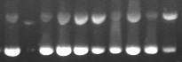
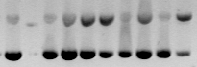
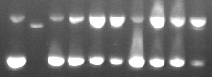
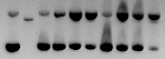
Eu(R/S)Naphdpq
Λ: 0 5 15 45 ∆: 0 5 15 45 mins

Tb(R/S)Naphdpq
0 5 15 45 0 5 15 45 mins

